The Influence of Hand Size on Touch Accuracy

【Summary】：

Touch accuracy depends not only on the performance of the touch sensor itself. Instead, it is shown that aspects such as phone holding or screen occlusion also affect accuracy. To better understand touch input, we investigated how 11 hand features affect accuracy.

【Important】Several factors influencing touch accuracy have been previously explored. For example, Holz and Baudisch have proposed that visual features on top of the touching finger determine the desired touch location [13]. Whether a target is in easy reach of the thumb [3], whether the thumb is curled or straight [22], as well as whether a user is multitasking [20] have all been shown to impact touch performance.

【Improving Touch Input】【The Thumb’s Influence on Touch Performance】

【DATA COLLECTION】：

Data collection is divided into two phases. Phase 1 consists of clicking on 1,000 crosshair targets, which then appear at random locations throughout the screen. Phase 2 includes five interactive tasks, each with 10 repetitions: swipe, scroll, pan, type, and select.

**Attributes:**

A set of gesture measurements were collected in each participant (see Figure 2). Measures include: (1) the width of the thumb pad (which may affect the touch size [13]), (2) the length of the index finger from the base of the thumb (this affects the extension of the thumb), (3) the span of the fingers between the thumbs And forefinger (this also affects the reach of the thumb [3] and the aiming angle of the thumb), (4) the span of the finger between the thumb and the little finger, and (5) the width of the palm (both affect the width of the grip). May affect the vertical stability of the phone); (6) the length of the palm (this affects the length of the handle, which may affect the horizontal stability); and (7-11) the length of each of the five fingers.

Device:

iPhone 6 and Nexus 6P

The former measures 13.8 × 6.7 × 0.7 cm smaller (screen diagonal 5.7), while the latter measures 15.9 × 7.8 × 0.7 cm (screen diagonal 4.7). In the current device environment, the Nexus 6P is medium in size, while the iPhone 6 represents a smaller class of phones.

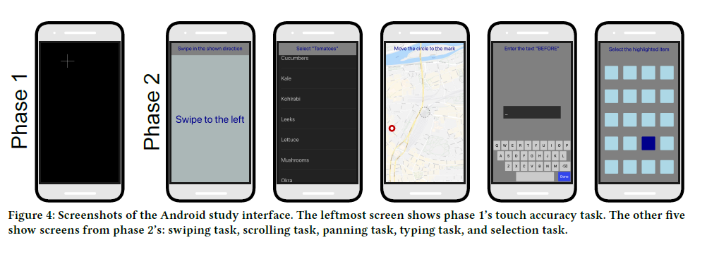

【Experiments】：

**E1-Touch Accuracy:**

In Phase 1, we collected speed and accuracy data to determine how anthropometric hand characteristics affect touch accuracy across the entire screen area. The task is to use your thumb to hit the 1 cm large crosshair target that appears on the screen (see Figure 4).

**E2-Recording Touch Patterns:**

In Phase 2, we collected touch pattern data to explore the potential relationship between anthropometrics and higher-level interactions. We collected data from five types of tasks that represent common interactions with mobile phones (see Figure 4). In addition to touch data, we also record device movement data (such as accelerometer readings).

**Swiping Scrolling Panning Typing Selection**

**Results:** (Detail in Paper)

1. **Overall Touch Performance**
2. **Hand Features’ Impact on Touch Error**
3. **HIGHER-LEVEL TOUCH INTERACTIONS**

**Discuss:**

Our analysis shows that the size of the hand and the length of the thumb can especially have a measurable effect on touch input. . . (See the discussion section of the paper for details)

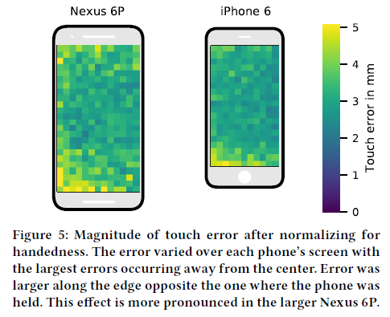 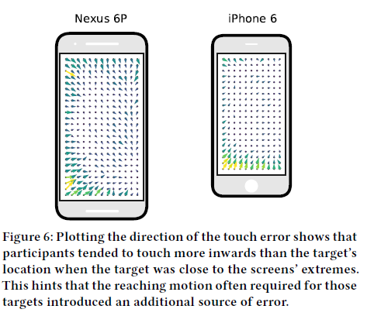

**【Conclusion】：**

We investigated the effect of hand size on touch input. The length of the thumb especially affects touch accuracy, explaining about a 12% difference. In addition, we have shown that metrics for higher-level touch interactions (such as swiping) are also related to thumb length.

【Important Reference】:

[2] Hrvoje Benko, Andrew D. Wilson, and Patrick Baudisch. 2006. Precise Selection Techniques for Multi-Touch Screens. In Proceedings of the SIGCHI conference on Human Factors in computing systems - CHI ’06. ACM Press, New York, New York, USA, 1263–1272. https://doi.org/10. 1145/1124772.1124963

[3] Joanna Bergstrom-Lehtovirta and Antti Oulasvirta. 2014. Modeling the functional area of the thumb on mobile touchscreen surfaces. In Proceedings of the SIGCHI Conference on Human Factors in Computing Systems. ACM, 1991–2000.

[13] Christian Holz and Patrick Baudisch. 2011. Understanding touch. In Proceedings of the 2011 annual conference on Human factors in comput-ing systems - CHI ’11. ACM Press, New York, New York, USA, 2501–2510. https://doi.org/10.1145/1978942.1979308

[22] Yong S. Park and Sung H. Han. 2010. One-handed thumb interaction of mobile devices from the input accuracy perspective. International Journal of Industrial Ergonomics 40, 6 (nov 2010), 746–756. https: //doi.org/10.1016/j.ergon.2010.08.001

[27] Daryl Weir, Simon Rogers, Roderick Murray-Smith, and Markus Löchtefeld. 2012. A User-Specific Machine Learning Approach for Improving Touch Accuracy on Mobile Devices. In Proceedings of the 25th annual ACM symposium on User interface software and tech-nology - UIST ’12. ACM Press, New York, New York, USA, 465–476. https://doi.org/10.1145/2380116.2380175